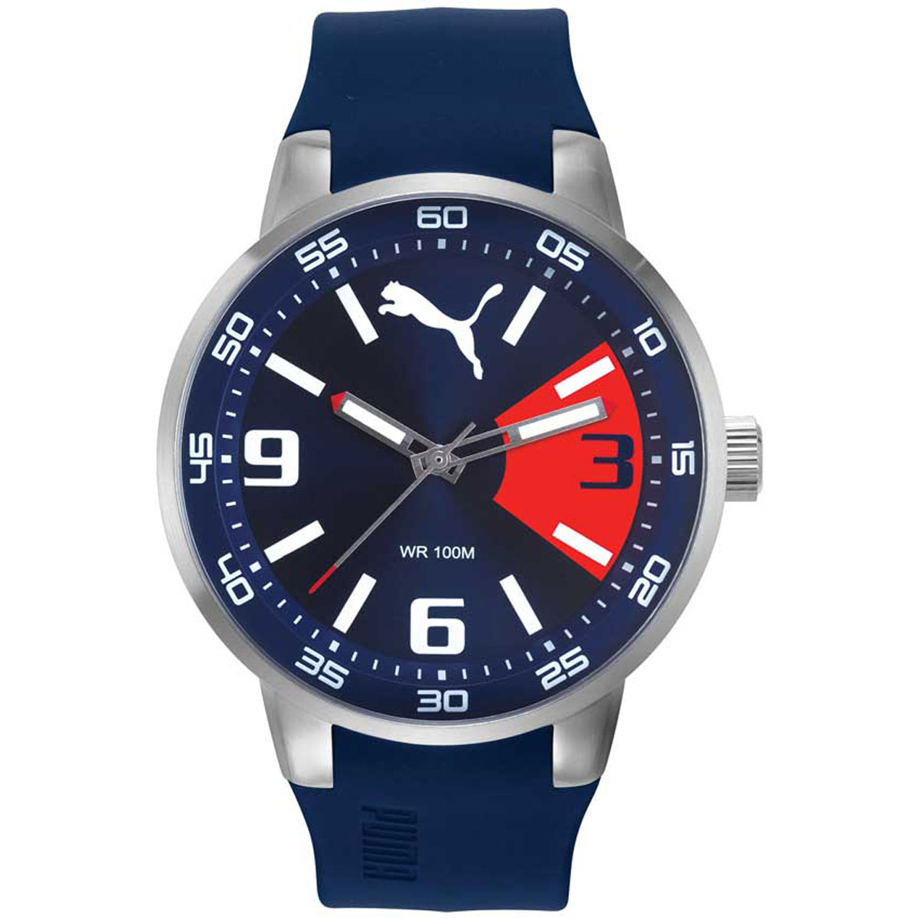Description: Puma is a well-known global sports brand that also produces stylish and functional watches. Puma watches are designed for active individuals who seek a blend of sporty aesthetics and everyday usability. These watches feature sleek and modern designs, often incorporating digital and analog displays, water resistance, and durable materials suitable for workouts and casual wear. Puma watches are lightweight, comfortable, and often include features like chronographs, alarms, and stopwatch functions, making them ideal for fitness enthusiasts. With their trendy look and reliable performance, Puma watches offer a perfect combination of fashion and functionality for those who love sports and an active lifestyle.